The No-Felt Zone…

We want our fiber beautiful and spinnable!
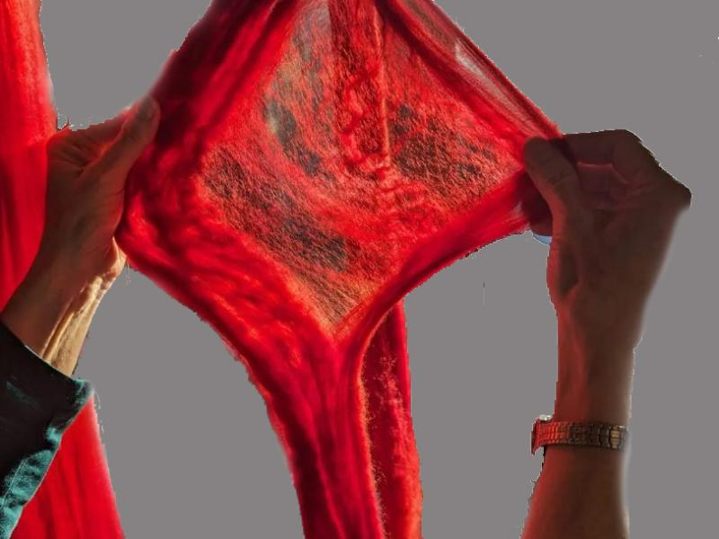

Why does wool felt or shrink?
- Scales on wool can lock together.
- Generally coarser wool has larger scales and felts more easily
- Combed top has all of the fibers aligned so is less likely to felt
- Heat, moisture, and agitation can help link scales
- Superwash wool either has the scales removed or covered with a polymer

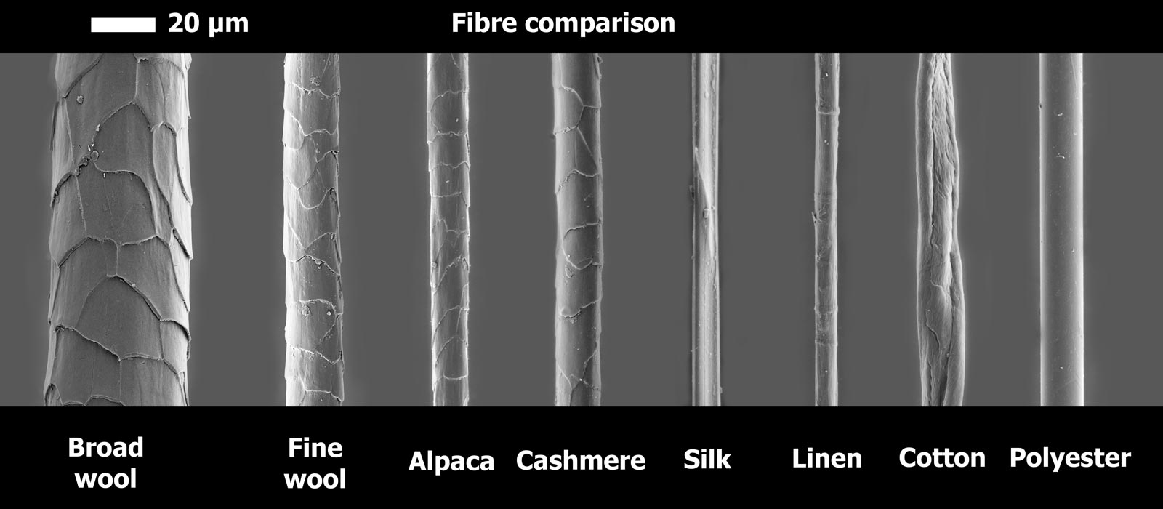
From https://www.woolmark.com/globalassets/_06-new-woolmark/_5-fibre/what-is-merino-wool/comparison.jpg
Human hair is 50 – 70 Microns

First and foremost is SAFETY:
- Powder of any kind in your lungs isn’t great
  - ALWAYS WEAR A MASK OR RESPIRATOR WORKING WITH DYE POWDERS
  - DYE IN A WELL VENTILATED AREA
- Remember – You are a protein and will dye too
  - WEAR APPROPRIATE CLOTHING, SHOES, AND GLOVES
- Mom’s not here
  - CLEAN UP MESSES AS THEY HAPPEN
- Good tools are to dye for, not from
  - ANY DYEING EQUIPMENT REMAINS DYEING EQUIPMENT
  - BE PREPARED FOR DYEING JOKES THAT WON’T DIE
- Jacquard Fire Red sorta looks like Kool-Aid
  - NO EATING, DRINKING OR SMOKING WHILE DYEING

Materials:
List of tools and supplies needed:

Mixing equipment
Essential | Nice to Have
Mask or respirator | Magnetic stirrer, beaker, magnetic stir rods
Gloves (nitrile or latex) | Clean-box
Apron | Syringe (1ml and 10ml)
Permanent marker | Graduated cylinder / flask or 1 liter bottles of water
Whisk/spoon | Balance or Scale (at least 0.1gram accuracy, better at .01gram)
Work area protection (eg. damp newspaper) | TOD Spoons (Triple Over Dye, or Grey’s / Gray’s Spoons)
Stock storage bottles (distilled water jugs, canning jars, etc.) | Funnel
Pyrex, plastic box, or pan for mixing | Condiment bottles
Paper/cotton towels
Volume measuring equipment
Cooking
Essential | Nice to Have
Heat source (stove, microwave, crock pot, oven, induction burner, butane burner, electric roaster, deep fryer, hot plate) | Nice: Timer
Large pot (stainless steel, enamel) | Bright light
Quart/pint jars | pH Meter / Strips
Apron
Jar lifter or insulated gloves
Chop-sticks or skewers (point down!)
or plastic tubing for individual jars
Thermometer
Tyvek for labels
Permanent marker (that doesn’t run when wet)
Acid
White Vinegar, 5% or
Citric Acid Powder (use 1 Tbl + 1 gal water to approximate white vinegar)
Acid Dyes
Dish Soap – wetting agent (no bleach!)

Background Information:

1% Dye Stock 1gram dye powder in 100ml water
DOS 1 (Depth of Shade) 1gram dye powder per 100 grams of fiber
Exhausted Dye Bath Most of the dye molecules are bonded to the fiber (water appears clear)

Metric –vs– English measures. Depth of Shade (DOS) and percentage calculation depends on accurate measurements. I find the metric system to be easier. You can, however, make predictable colors using English measures; you just need to be consistent in how you mix your stock solutions and keep good records.

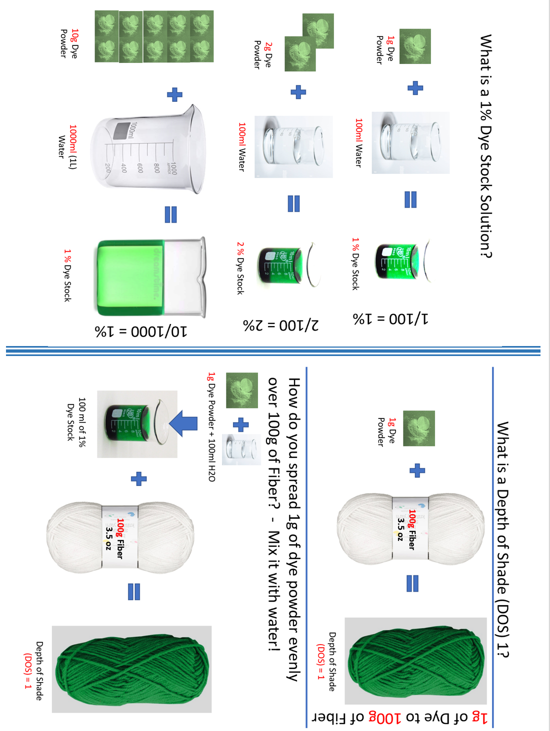

Mix Dye
- Put dye powder into hot water in the mixing container (no breeze, fan).
- Mix using a whisk, magnetic stirrer or shaking. - NO lumps
- Put in storage container (use a funnel if needed).
- Mark container with: date, brand, type and color/number of dye.
- Store container in a SAFE, cool place.

Dye your fiber - Painting
- Wet fiber in hot water with several drops of dish soap for 20 to 30 minutes.
- Express water.
- Lay out fiber on plastic wrap and paint with dye. Sop up any extra dye.
  - No Poking!
- Spray with white vinegar or citric acid water.
- Flip. Touch up undyed areas. Sop up any extra.
- Spray with acid.
- Cover with plastic wrap and seal both long edges.
- Burp excess air out to an end and seal. Burp remaining air and seal opposite end.
- Place in steamer or microwave.
- Turn heat on to high and monitor for the poofing of the plastic wrap.
- Once it poofs, turn heat down to medium or low (whatever is needed to maintain the poof) and time for an hour (generally).
  - For microwave, heat periodically – no boiling.
- Turn off heat and allow to cool completely.
- Wash for 2 minutes in cold water (70F) with a drop of detergent and acid.
  - Amount of acid depends on volume and pH of water.
- Express water.
- Rinse fiber in cold water and acid for 10 minutes.
- Express water.
- Repeat rinse as needed. Spin out excess water.
- Hang fiber or lay item flat to dry out of direct sunlight.

Dye Your Fiber – Low Water Immersion
- Presoak fiber in acid water – for 20 up to 120 minutes.
- In pot, very little water will be used so you’ll need to judge. Fiber shouldn’t be on the bottom of the pot to burn because that would be sad.
- Put water and acid in pot.
- Express excess water from fiber.
- Place fiber in the pot.
- Add dyes in planned or random order but be careful with the volume.
- Press fiber down to submerge it.
- Carefully heat. If you dye fiber with silk, do not go above 185F as it will harm the silk.
- Check to make sure color has penetrated through to the underside of fiber. Flip and treat undyed areas.
- Cook for 30 minutes, cover, and turn off pot to cool completely.
- Wash as above.

Repeatable painting
- Jig for consistent length
- Map for color placement

Keep notes on “experiments”

Sample note pages follow:

Dyeing sample notes
Fiber type: ________________________________________
Fiber Preparation (e.g. combed top): ____________________
Dyeing technique: ___________________________________
Method description/notes:

Results:
Color evenness, penetration, saturation:

Degree of felting:

De-felting method and results:

Dyeing sample notes
Fiber type: ________________________________________
Fiber Preparation (e.g. combed top): ____________________
Dyeing technique: ___________________________________
Method description/notes:

Results:
Color evenness, penetration, saturation:

Degree of felting:

De-felting method and results:

Dyeing sample notes
Fiber type: ________________________________________
Fiber Preparation (e.g. combed top): ____________________
Dyeing technique: ___________________________________
Method description/notes:

Results:
Color evenness, penetration, saturation:

Degree of felting:

De-felting method and results:

Dyeing sample notes
Fiber type: ________________________________________
Fiber Preparation (e.g. combed top): ____________________
Dyeing technique: ___________________________________
Method description/notes:

Results:
Color evenness, penetration, saturation:

Degree of felting:

De-felting method and results:

