The No-Felt Zone…

We want our fiber beautiful and spinnable!
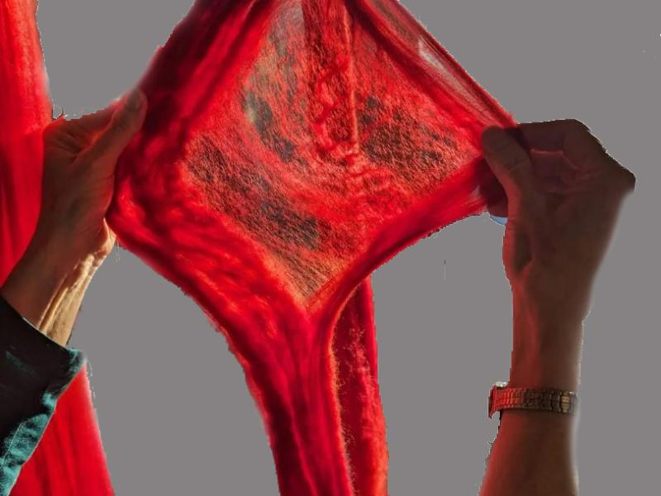

Why does wool felt or shrink?
- Scales on wool can lock together.
- Generally coarser wool has larger scales and felts more easily
- Combed top has all of the fibers aligned so is less likely to felt
- Heat, moisture, and agitation can help link scales
- Superwash wool either has the scales removed or covered with a polymer

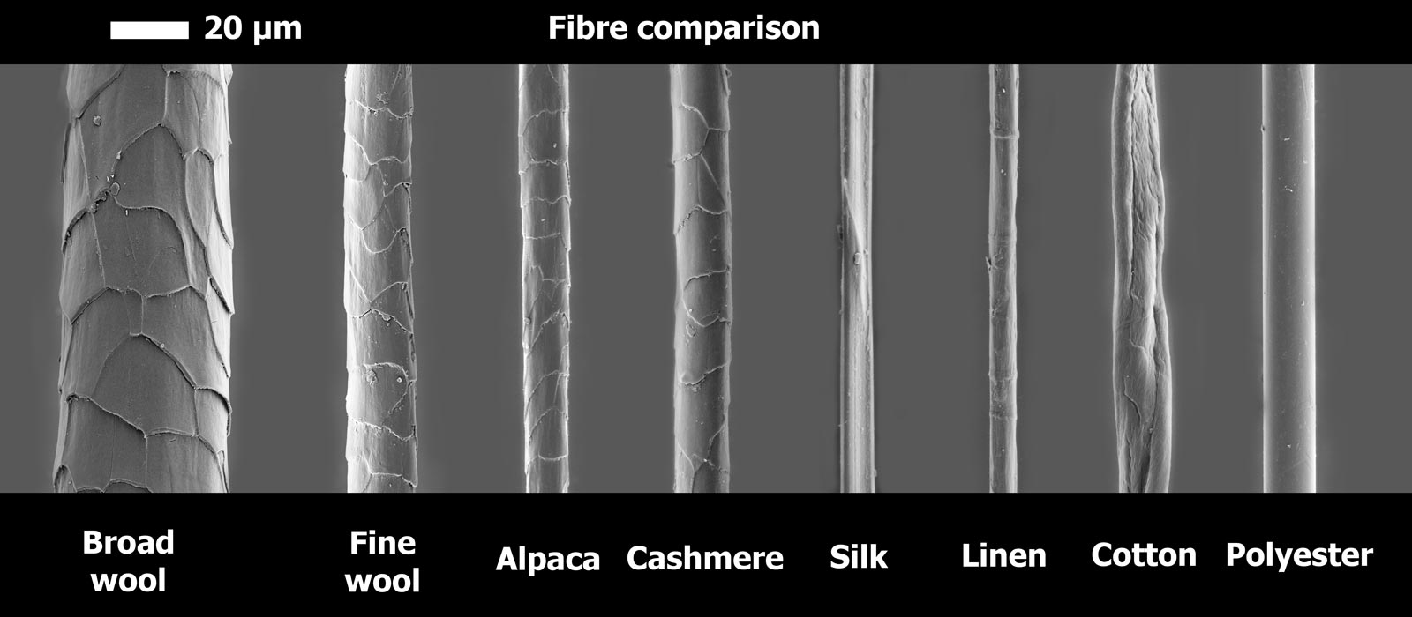
From https://www.woolmark.com/globalassets/_06-new-woolmark/_5-fibre/what-is-merino-wool/comparison.jpg
Human hair is 50 – 70 Microns

